**The time machine**

***The Time Machine*** is a [science fiction](http://en.wikipedia.org/wiki/Science_fiction) [novel](http://en.wikipedia.org/wiki/Novella) by [Wells](http://en.wikipedia.org/wiki/H._G._Wells). It was published in 1895.

Later it was adapted into many films and works of [fiction](http://en.wikipedia.org/wiki/Fiction).

The trailer: <http://www.youtube.com/watch?v=ZJuHV3BXGm0>

**Information about famous people:**

1. Guglielmo Marconi, 1874, Italy, 1, B (physicist)

2. Edith Piaf, 1915, France, 3, C (singer)

3. José Martí, 1853, Cuba, 7, D (writer, politician)

4. Pablo Neruda, 1904, Chile, 5, F (poet)

5. Alessandro Volta, 1745, Italy, 2, G (physicist)

6. Pablo Picasso, 1881, Spain, 4, I (painter)

7. Oscar Wilde, 1854, Ireland, 8, J (writer)

8. Buster Keaton, 1895, U.S.A., 9, H (actor)

9. Charles Dickens, 1812, England, 6, C (writer)

**Travel through time and meet some famous people. Look at the example and do questions according to the information in the pool.**

*Example: Mark Twain, 1835, U.S.A., 4, E.*

1. *When were you born?*

*I was born in 1835.*

1. *Where were you born?*

*I was born in U.S.A.*

1. *Where were you?*

*I was at the restaurant.*

1. *When were you at the restaurant?*

*Four days ago, I was at the restaurant.*

**WHERE…?**

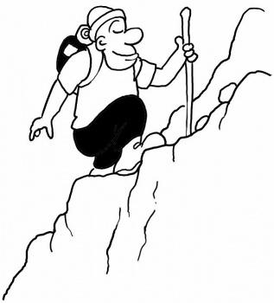 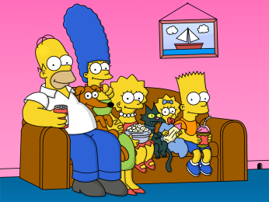  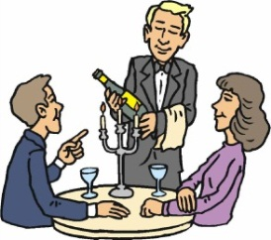 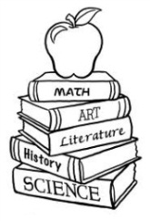 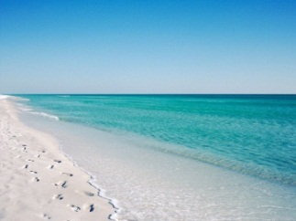 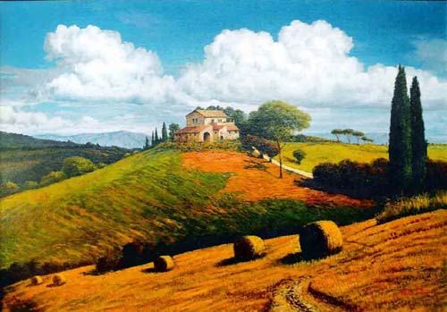  

**65**

**7**

**8**

**9**

**5**

**4**

**3**

**2**

**1**

**WHEN…? (today is 29th January)**

**25**

**24**

**23**

**22**

**1999**

**December**

**26**

**27**

**28**.6

**29**

**GA**

**HA**

**D**

**E**

**F**

**Gg**

**Hh**

**J**

**PAST**

**PRESENT**

**Iih**

**C**

**B**

**A**